Welcome to ConnectED
ConnectED is your gateway to your online curriculum resources. This document explains how to access ConnectED and what certain features do.

Logging In
To log in to your content, you will need a Username and Password. Your teacher will be able to provide these to you:
- Go to http://connected.mcgraw-hill.com for the ConnectED Login screen.
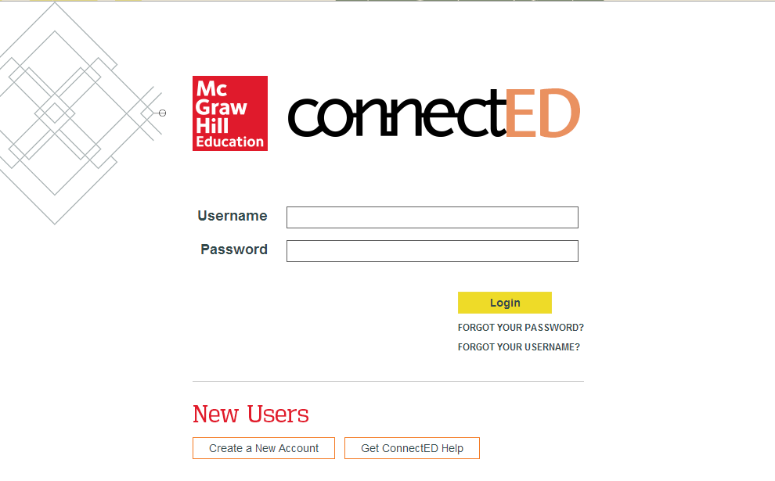

- Enter your Username and Password and click Login to display your Books and Content page.
To Do: Click this to see what the teacher has assigned.
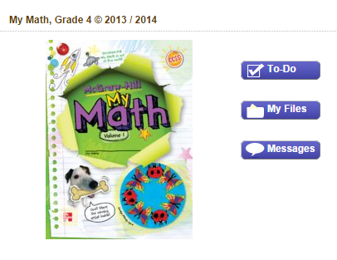
My Files: Click to see specific homework or worksheets.
Messages: Click for important notes or announcements from the teacher.
Click the book to open the Student Center.

- Your Student Center lets you open your class information, as well as other materials.
Resources: The online tools that are connected to the lesson.
Collaborate: Place for students to have online discussion to solve problems collaboratively

Homework: Your latest assignment.
Messages: Important notes or announcements from the teacher.
Find your place: Drop down menus guide you to the lesson pages.

Using the System Links:
System Links are located in the upper right corner of the screen.
Click ConnectED to
return to your Books and the Content page.

Click Logout to log out of ConnectED.

Using the Help:
You can see more information on the ConnectED Help page. This page has tutorials and user guides to help you understand how to use ConnectED.
Click Get ConnectED Help on the ConnectED Welcome page.

